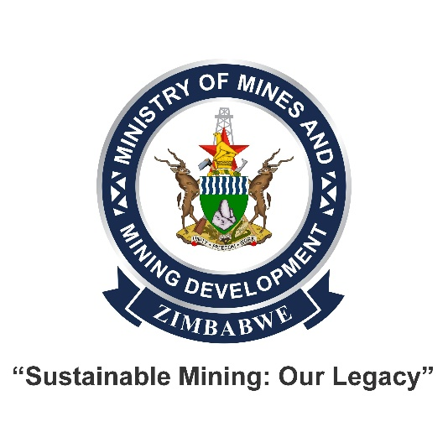
PUBLIC NOTICE
22 May 2026

TO ALL HOLDERS OF MINING TITLES AND MINING OPERATORS: Call to Regularise Outstanding Obligations
The Ministry of Mines and Mining Development hereby notifies all valued stakeholders with outstanding fees to the Ministry to settle their debts no later than 30 August 2026.
Failure to comply within the stipulated timeframe may result in forfeiture. Stakeholders are further advised to visit their respective Provincial Mining Offices to obtain their invoices.

Issued: 10 July 2026
Dr. Thomas U. Wushe
Permanent Secretary
Ministry of Mines and Mining Development

Ministry of Mines and Mining Development

mmmd@mines.gov.zw

Cnr Leopold Takawira Street/ Kwame Nkrumah Avenue 6th Floor, Harare, Zimbabwe


P.O. Box CY 7709,
Causeway, Harare, Zimbabwe

mmmd@mines.gov.zw


mmmd@mines.gov.zw

mines.gov.zw

+263 242 777 029,798775 +263 242 759895, 755612
+263 242 777022, 777029

